Mrs Whitehouse – Revisiting to the Residences and Vacation Homes of Jacqueline Kennedy Onassis
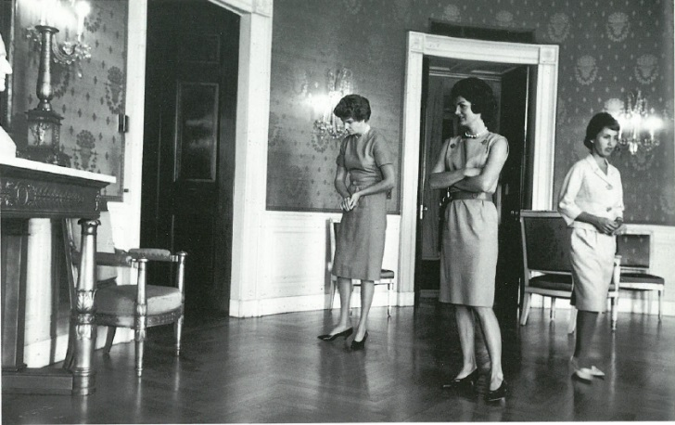
Jacqueline Kennedy working on the redecoration of the White House
Source: Time INC
In 1996 and again in 2005, Sotheby’s was extended the unique privilege to offer the Estate of Jacqueline Kennedy Onassis and to commemorate her life as a First Lady, wife, mother and collector at auction. Over the course of the exhibition, countless visitors wrapped around Sotheby’s New York headquarters, waiting patiently to experience firsthand the objects, accents, and keepsakes so intimately connected to her life. Even today, the Kennedy sales at Sotheby’s are considered to be one of the most historic and celebrated moments in the company’s long history – and the catalogues remain among the most coveted. The success of the Kennedy sale (which sold at approximately seven times its original estimate, a portion of the proceeds donated to the John F. Kennedy Library Foundation) was second only at the time to the sale of the Duke and Duchess of Windsor. As Diana Brooks, the then-Sotheby’s President commented: “The success of [the] auction does not belong to Sotheby’s” but rather to Mrs Kennedy whose grace, style, dignity and courage were behind the sparkling results.
Remembered for her taste, the interiors of Mrs Kennedy’s homes speak to her personal interests – with an emphasis on her adoration of horses and foxhunting – as well as her love of history. In their foreword to the sale catalogues, her children Caroline and John Kennedy remember how “history came alive through [her] objects and paintings.” In Mrs Kennedy’s collection of paintings, furniture and decorative arts, objects of historical importance stood alongside treasures from her visits to local antique shops nearby each of her homes. Each element of her collection spoke to her taste. She had the eye of a developed collector, acquiring pieces that she connected with rather than purchasing for investment or for show. This was very much in keeping with the guidance of her social secretary as First Lady, Letitia Baldrige, who commented: “Good taste is synonymous with success in all fields of life. It is not a question of money, but of a trained eye.”
Over the course of her adult life, Mrs Kennedy lived between many homes including the White House, a Manhattan apartment on the Upper East Side, a vacation home Hyannis Port, a cottage in Martha’s Vineyard, a weekend retreat in Peapack, New Jersey, and a foxhunting cottage in Virginia. Today we step back in time and to revisit the images of each of Mrs Kennedy’s unique residences:
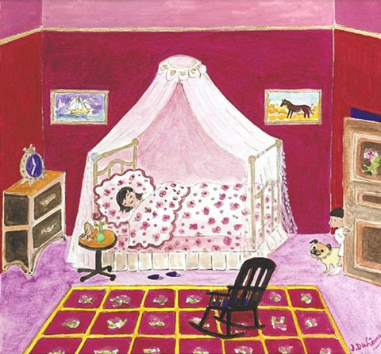
Jacqueline Duhême, Resting Up, London, March 26, 1962, watercolor on paper
Source: Sotheby’s
Mrs Kennedy’s Bedroom and Dressing Room, The White House
Jacqueline Kennedy’s infamous pale blue bedroom and dressing room at the White House epitomize the First Lady’s elegant style. Designed in partnership with Dorothy Mae “Sister” Parish, the intention was to transform the First Lady’s rooms into a private sanctuary where she could feel at home. Chinese porcelain, English and French furniture, and European keepsakes are featured throughout, alongside the signature aqua Tillet Textiles Daisy cotton print which was created specifically for Mrs Kennedy’s bedroom.
Although the photographs of her private residence at the White House (and the White House Restoration project in 1961) characterized the First Lady as an accomplished and passionate decorator, she was not known to have enjoyed the decorating process and moved many works of art and possessions to her Manhattan apartment from her residence in the White House. As a result, we can see many of her most beloved possessions from the White House residence across many of the images of her private homes:
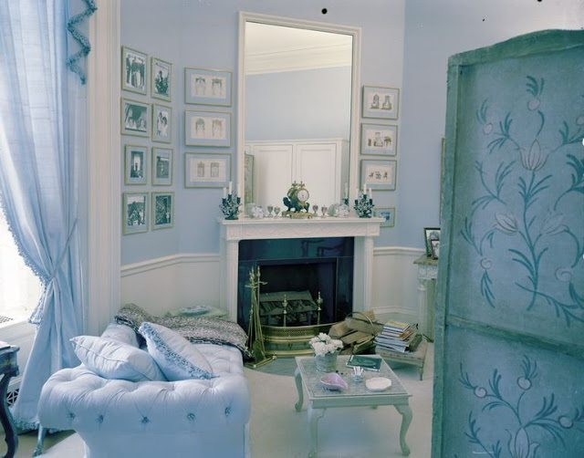
View of Mrs Kennedy’s Dressing Room at the White House
Source: White House Museum
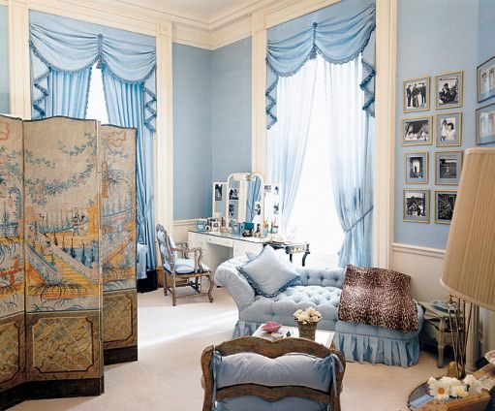
View of Mrs Kennedy’s Dressing Room at the White House
Source: Architectural Digest
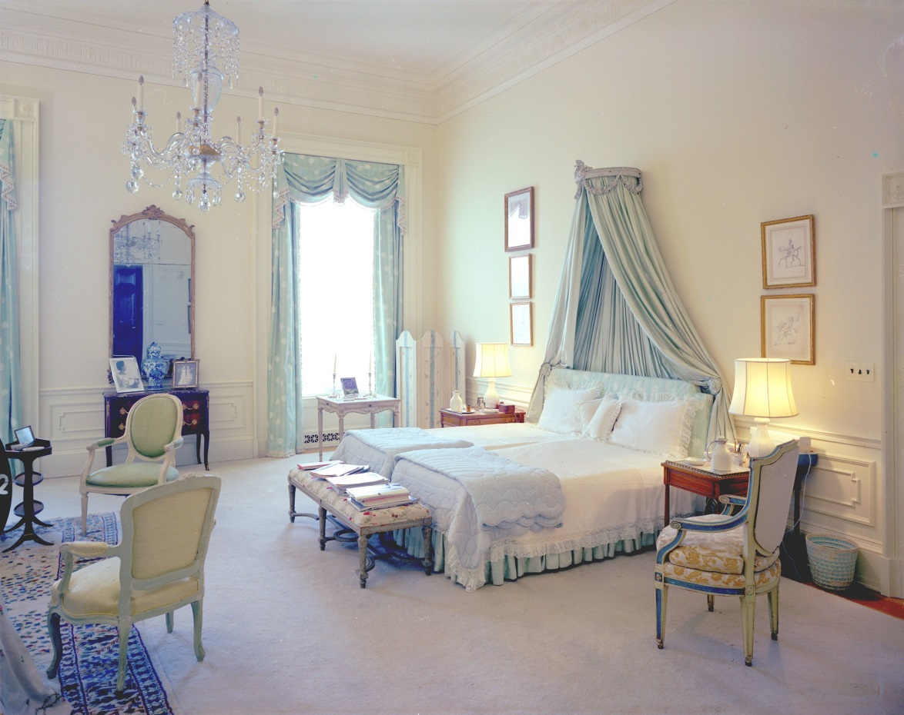
View of Mrs Kennedy’s Bedroom
Source: Architectural Digest
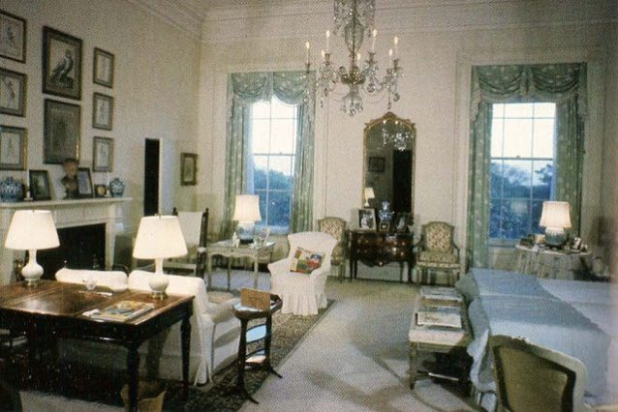
View of Mrs Kennedy’s Bedroom by Sister Parish, 1961
Source: John F. Kennedy Library
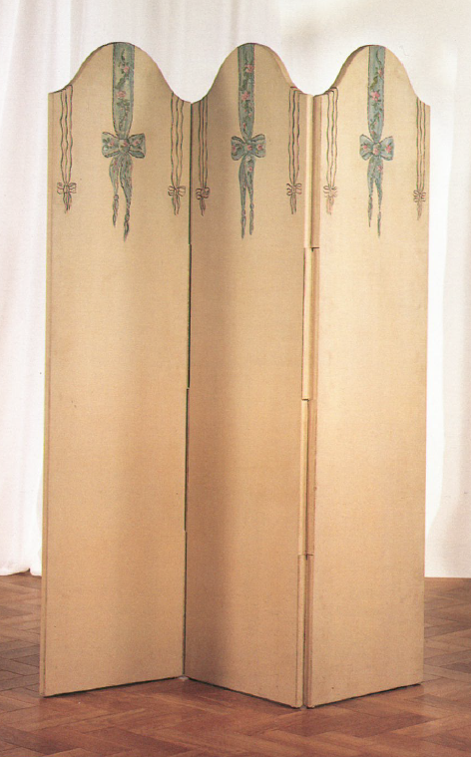
Three-Panel Painted Canvas Screen decorated with Floral Ribbons and Sprays of Flowers
From Mrs Kennedy’s bedroom at the White House
Source: Sotheby’s
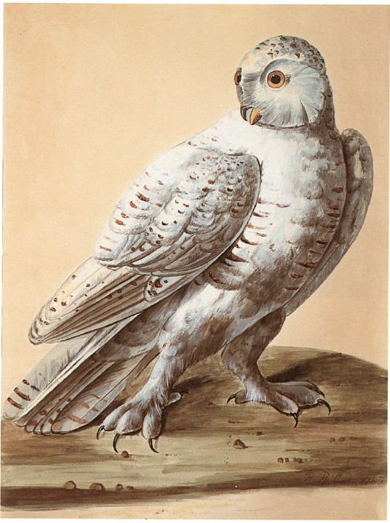
Peter Paillon, Study of a Snow Owl, gouache and watercolor
Hung above the fireplace in Mrs Kennedy’s Bedroom at the White House
Source: Sotheby’s
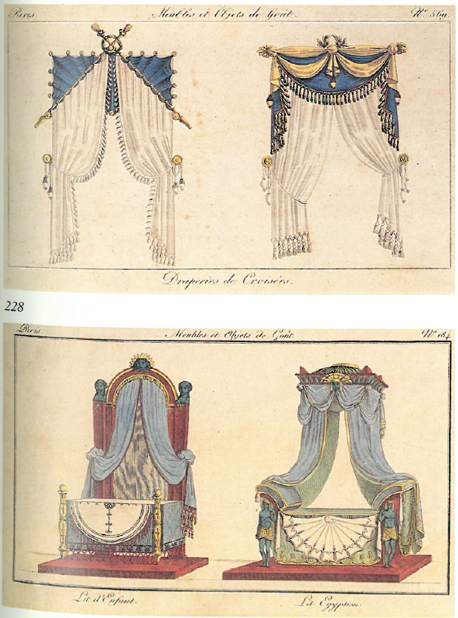 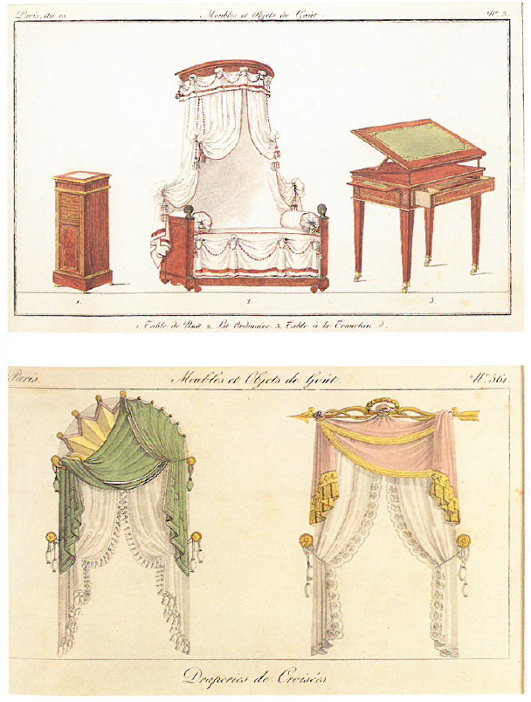
French Interior and Window Drapery Designs
These engravings were among the furnishings in Mrs Kennedy’s Dressing Room at the White House
Source: Sotheby’s

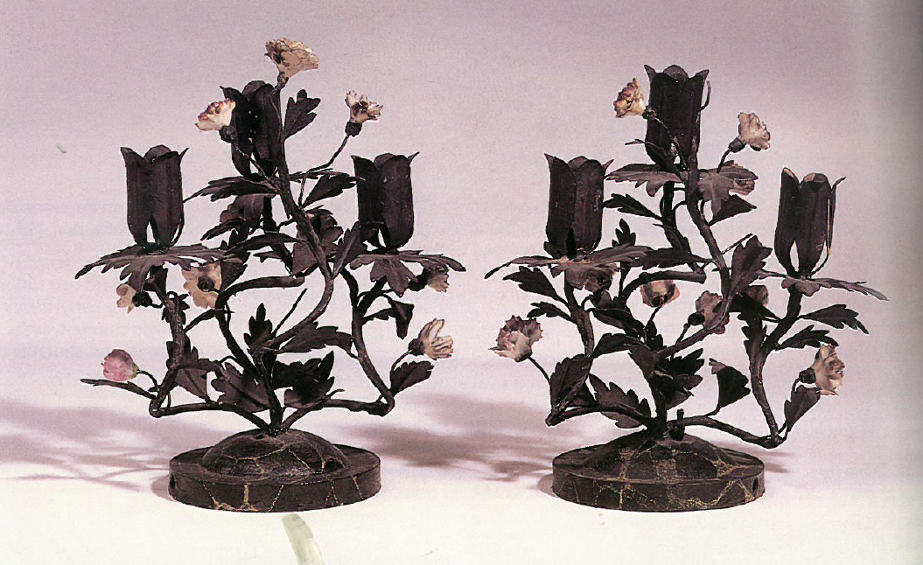
A Pair of French Painted Tôle and Hard-Paste Porcelain Three-Light Candelabra
These candelabra were among the furnishings in Mrs Kennedy’s Dressing Room at the White House
Source: Sotheby’s
New York Apartment, 1040 5th Avenue
Mrs Kennedy (then Mrs Onassis) lived in her Upper East Side apartment at 85th Street for thirty years. It was alleged that shortly after Mrs Kennedy moved into the building, the doorman accidentally directed two visitors to her apartment rather than to the residence of Mr and Mrs Whitehouse, another tenant in the building.
The building was designed by Rosario Candela, and each of the main rooms (living room, dining room, library and master bedroom) overlooked the Central Park Reservoir, later renamed the Jackie Onassis Reservoir in her memory. The décor was inspired by Mrs Kennedy’s interest in and love of France where she lived as a student years prior. French fabrics, paneling and furniture feature throughout the apartment, as do fireplaces and fresh flowers she was known to love (“cornflowers in the spring, dried hydrangea in the fall and lady apples in the winter”).
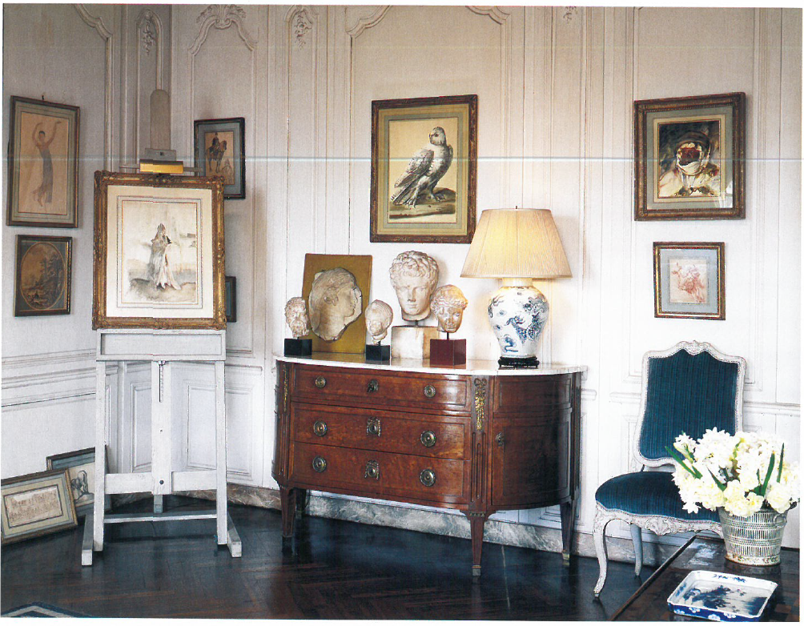
View of 5th Avenue Apartment
Source: Sotheby’s
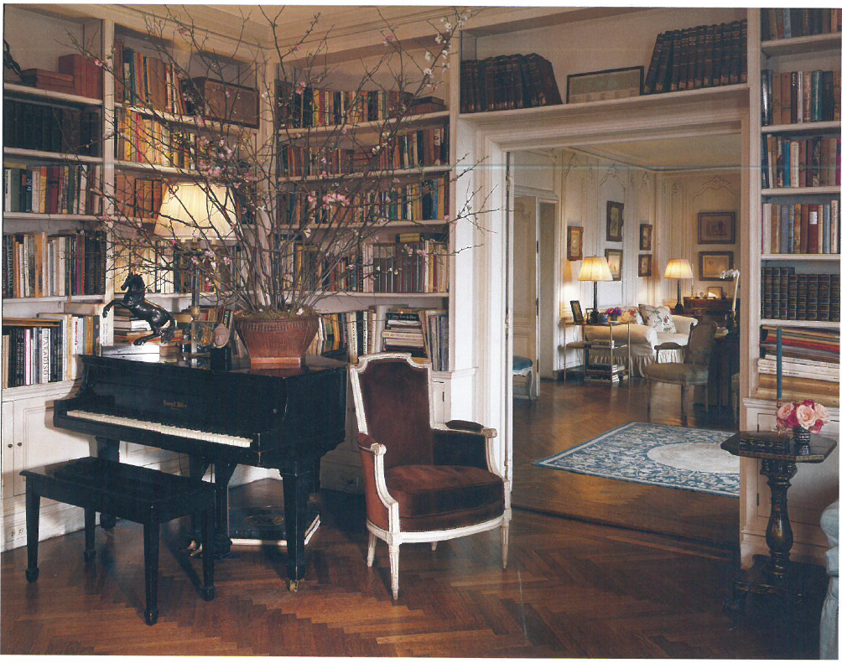
View of 5th Avenue Apartment
Source: Sotheby’s
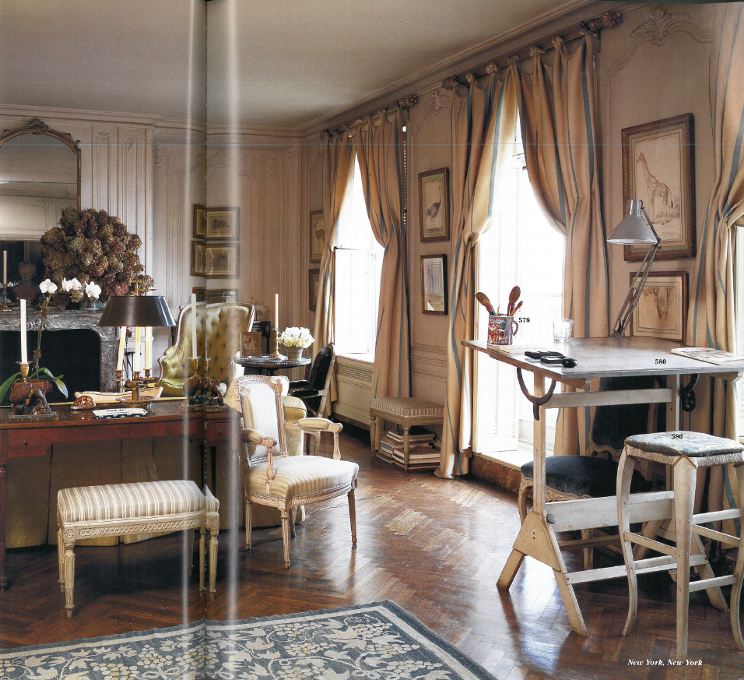
The Living Room, 5th Avenue Apartment
Source: Sotheby’s
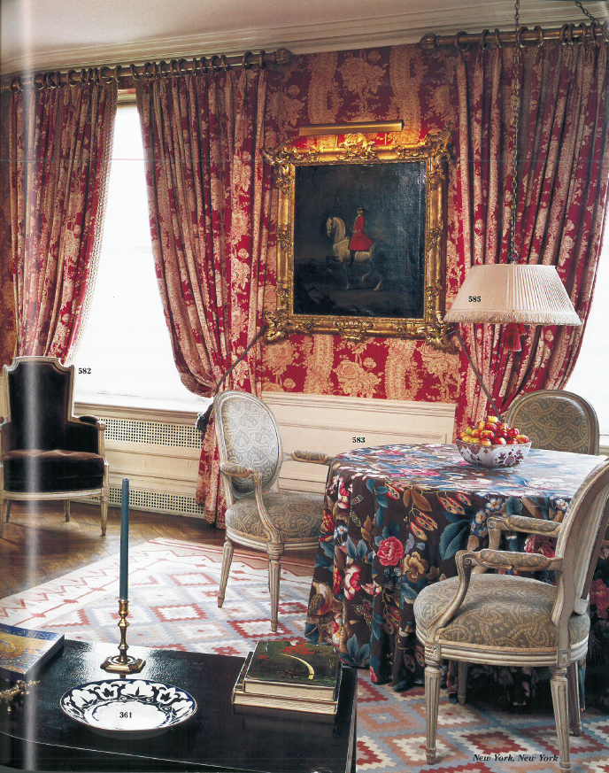
The Dining Room, 5th Avenue Apartment
Source: Sotheby’s
Hyannis Port, Massachusetts
The Hyannis Port residence was purchased by President and Mrs Kennedy in 1956 when he was a Senator, close by to two homes owned by the Kennedy family on Nantucket Sound. The design style is traditional of Cape Code vacation homes, with charming and cozy interiors decorated with American furniture, hooked rugs, ceramics and an extensive collection of sandwich glass made in New England. The Kennedy’s Hyannis Port home served as a summer White House while President Kennedy was in office. It was reported that he learned he was the Democratic presidential nominee while staying in Hyannis Port with his family, when daughter Caroline woke him saying “Good morning Mr President.”
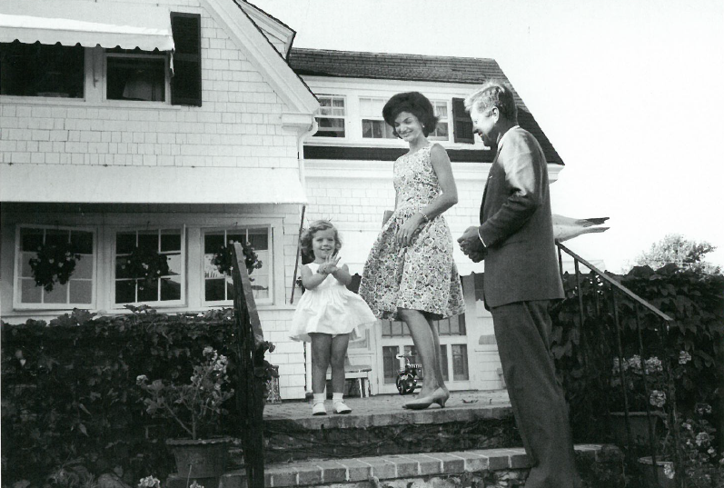
Hyannis Port, July 1960
Source: Sotheby’s
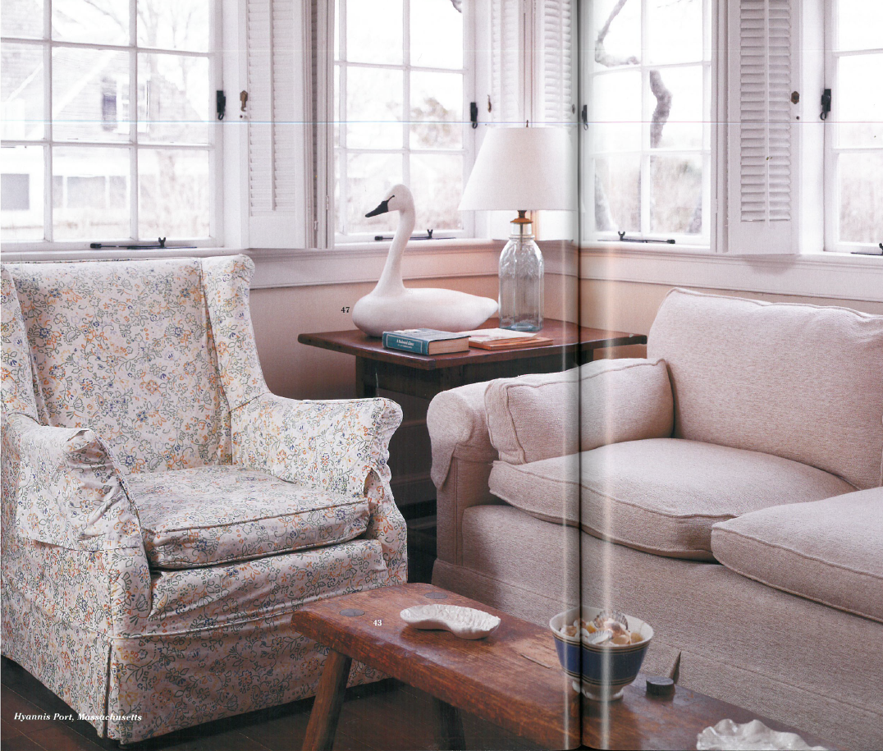 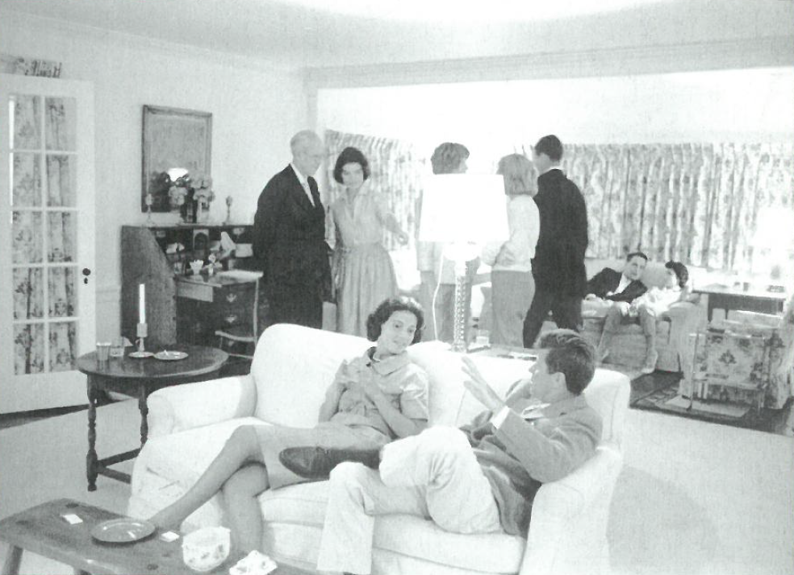
(1) Sitting Area, Hyannis Port (2) Hyannis Port, c. 1960
Source: (1) Sotheby’s (2) Sotheby’s
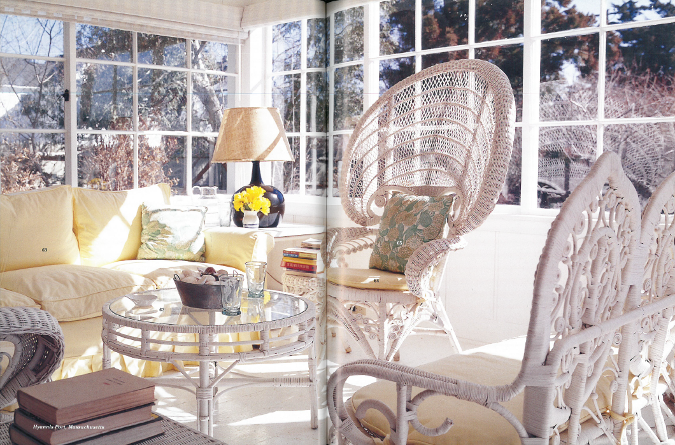 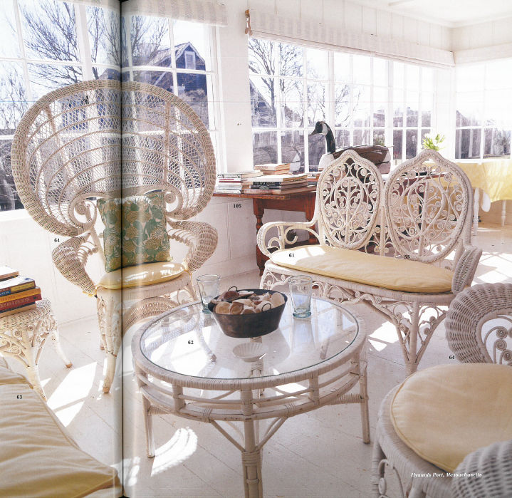
Sun Room, Hyannis Port
Source: (1) Sotheby’s (2) Sotheby’s
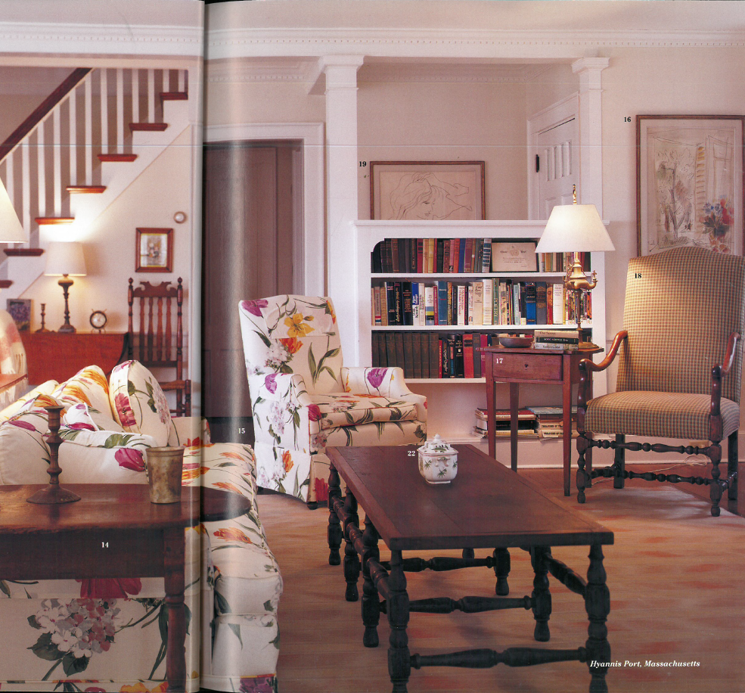
The Living Room, Hyannis Port
Source: Sotheby’s

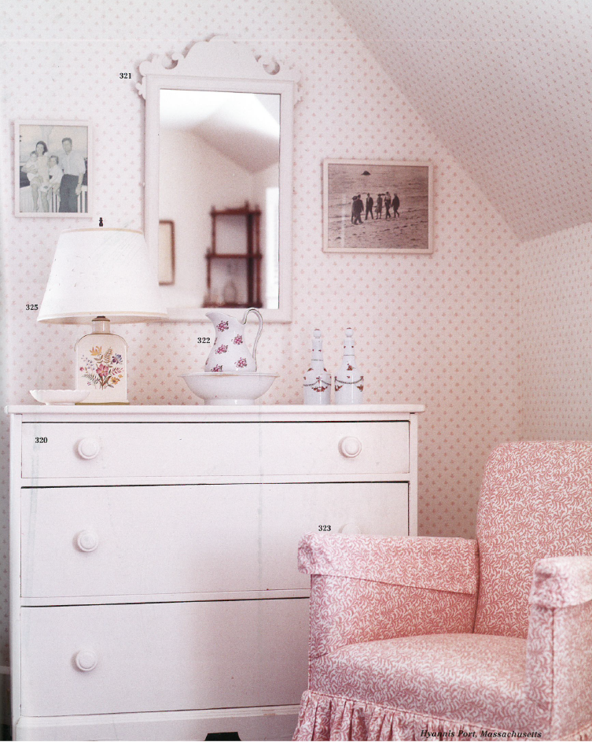 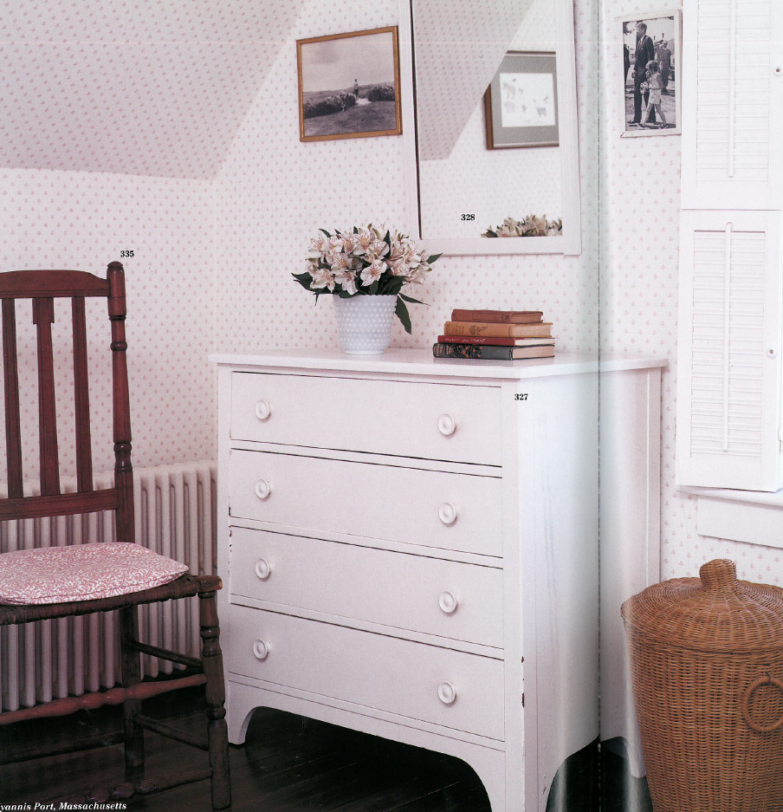
Bedroom, Hyannis Port
Source: (1) Sotheby’s (2) Sotheby’s
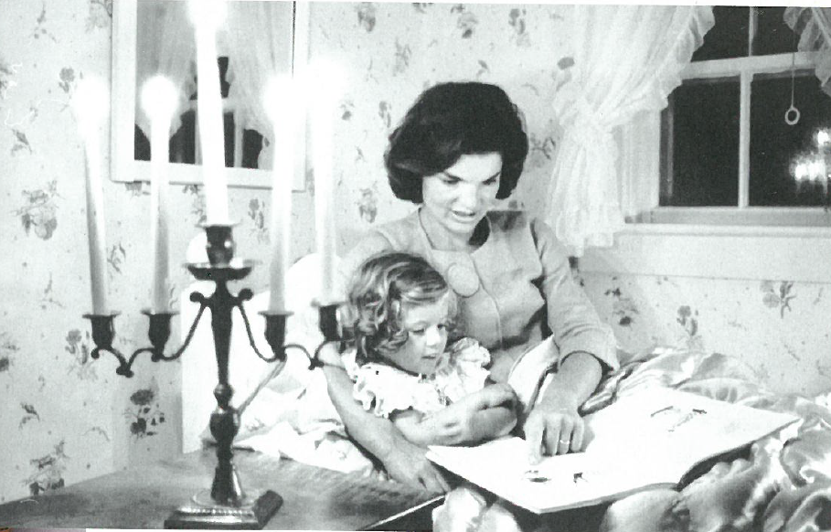
Jacqueline Kennedy Reading to Caroline in a Bedroom, Hyannis Port, September 1960
Source: Sotheby’s
Peapack, New Jersey
In the mid-1990s, Mrs Kennedy (then Mrs Onassis) began to spend weekends away from Manhattan in Peapack, the hunt country of New Jersey. The property was a converted barn in a valley ideal for horse riding and fox hunting, which she had loved from a young age. The house had a large room used as a living and dining room, a library with floor to ceiling bookcases and several bedrooms. It is understood that Mrs Kennedy celebrated many Thanksgivings and birthdays with her children in Peapack.
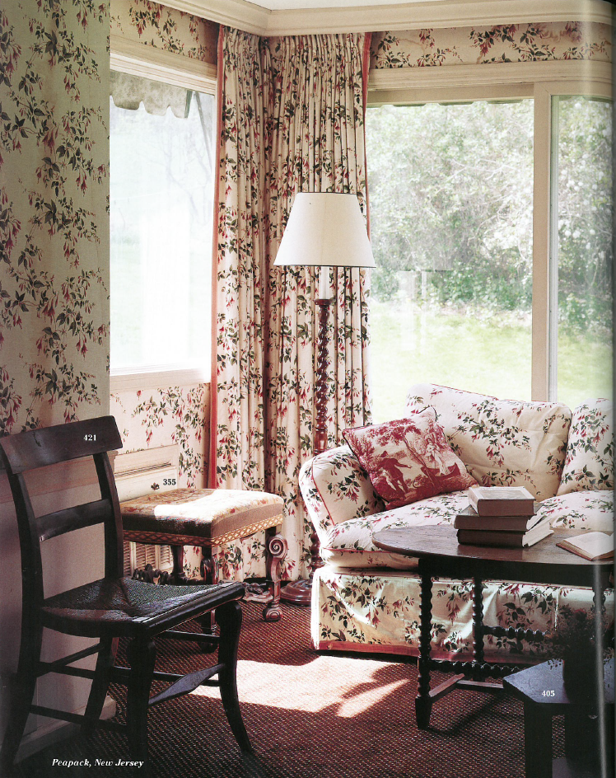
The Family Room, Peapack
Source: Sotheby’s
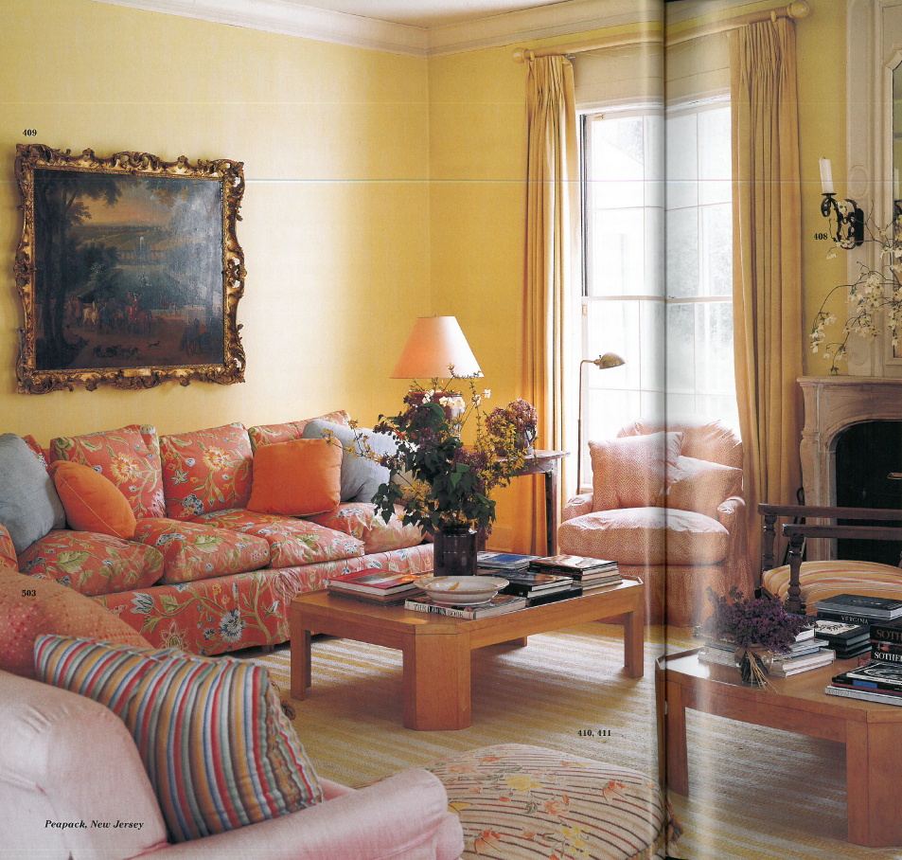
The Living Room, Peapack
Source: Sotheby’s
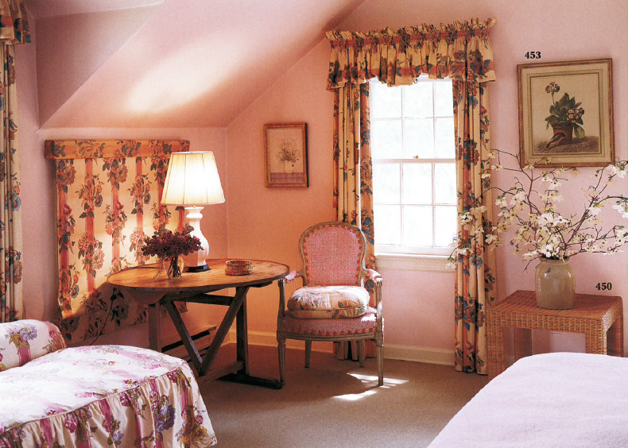
Bedroom, Peapack
Source: Sotheby’s
Martha’s Vineyard
The family home in Martha’s Vineyard overlooking the Atlantic Ocean was purchased by Mrs Kennedy (then Mrs Onassis) in 1979. The décor was inspired by the quintessential New England sea cottages and intended to be a summer house for the family. The property included a tennis court, meadow and vegetable garden and the interiors were decorated with Mrs Kennedy’s collection of Audubon prints of birds native to the island, as well as marine inspired works of art.
Virginia
Mrs Kennedy (then Mrs Onassis) also owned a home in Virginia which she purchased in the 1990s when she began to spend more time riding there with friends where she had fox hunted as First Lady. The cottage was nearby Wexford, and furnished with local antiques and French toile wallpaper.

