Curating Your Aesthetic: The Glam Pad’s Top Tips

Natalie Aldridge

While here at The Glam Pad we are proponents of traditional interiors, we celebrate individualism and the pursuit of finding one’s style of decoration. Even within the realm of classical interiors lays room for expression and the breaking of the confines of tradition. This task, however, can be a daunting challenge requiring the development of a personal aesthetic. Here at The Glam Pad we often receive inquiries about how to do just that.

As purveyors of inspiration, we have broken down our top tips for curating your decor aesthetic.

- Start collecting!

This is your free pass to be a tad of a hoarder. And of course, we mean in the chicest way. Collecting objet allows your interests to shine through in an interior. Expensive or not, acquiring goods of a common theme suddenly offers a moment of unmatchable decoration.

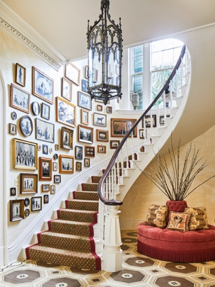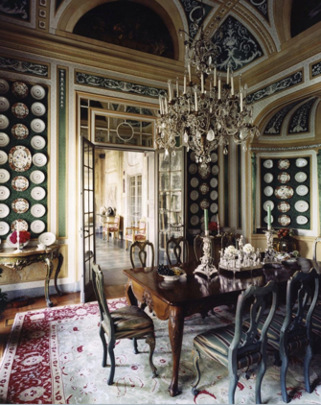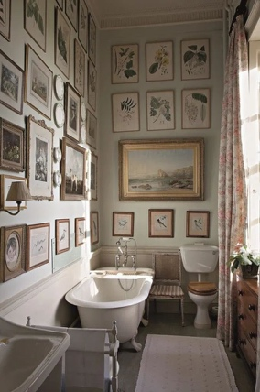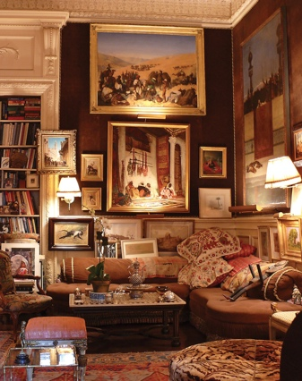

- Watch Movies

We carry moments of films with us throughout our whole lives. Subconsciously these moments influence our style, interests, and even personality. Making the effort to watch movies out of your typical wheelhouse can offer exciting aesthetic experiences. Spiraling down the rabbit hole of a particular director, era, or avant-garde genre opens the door undiscovered realm of inspiration.
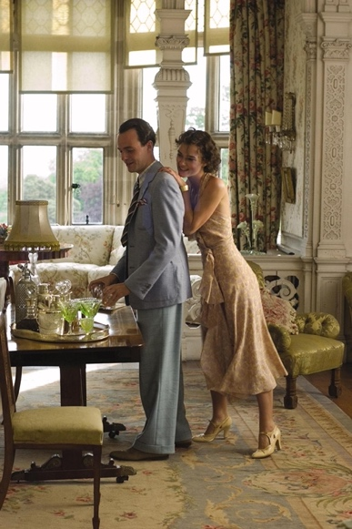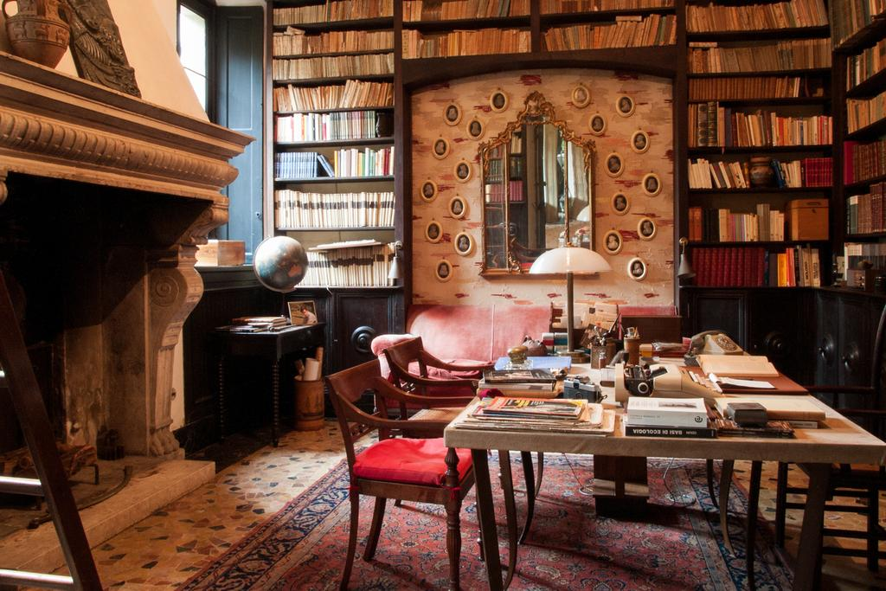
- Collage

And we don’t mean pinning! The act of physically collaging brings tangibility to the exercise. Tearing pages of old magazines, thrift books, pasting cloth scrapes, photographs, and more allows one’s mind to wander and discover. Reappearing motifs that emerge in your collaging can be worked into the home by way of color, artwork, and fabric.
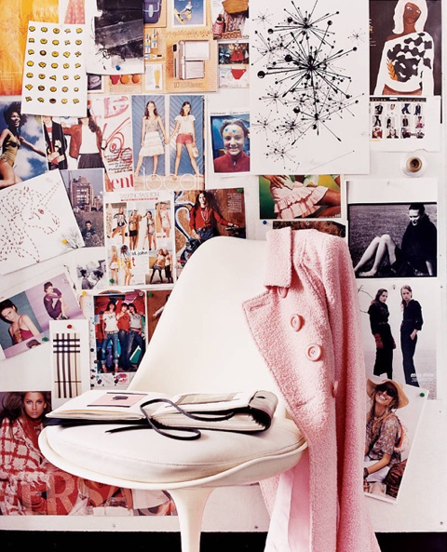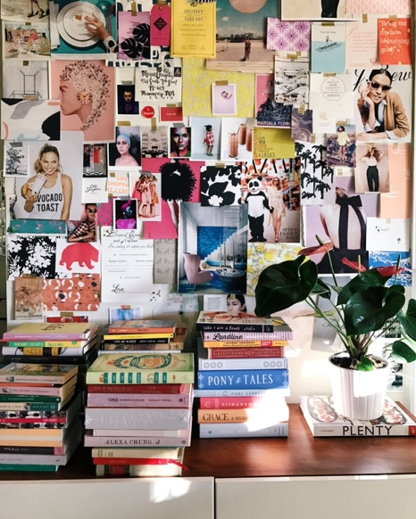
- Read It All

Read as much as you can. Revisit old and new books. Read coffee table books, don’t just buy them to sit on a table (we are all guilty of this). Document your findings, take notes, make doodles, manifest the visual feast within the text.
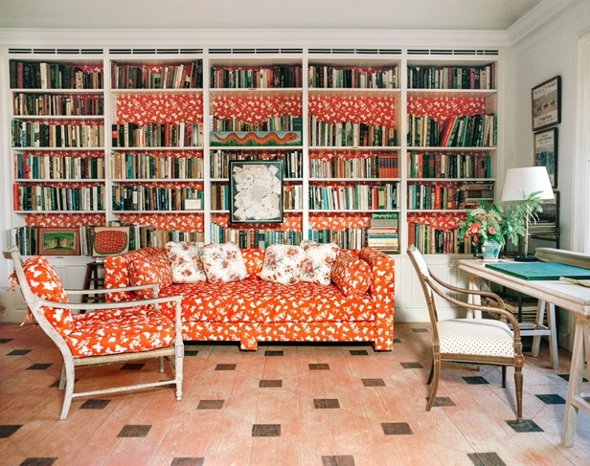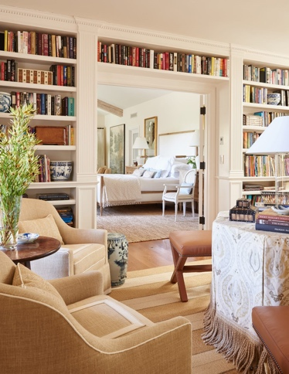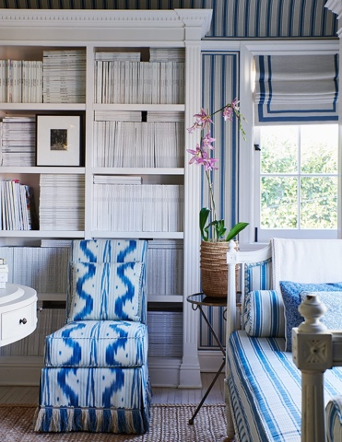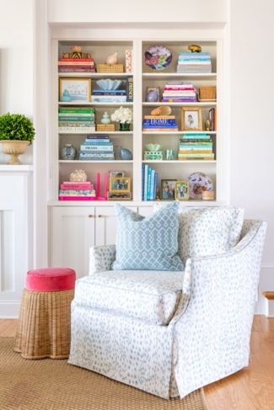
- Release Any Fear

One of the most vital components of honing an aesthetic is being fearless. After all, interior style and all that comes in between are personal interpretations. Emulation of a particular style should be infused with your sensibility and there truly are no rules to that.
