Kips Bay Palm Beach 2022 Recap

Written by Natalie Aldridge

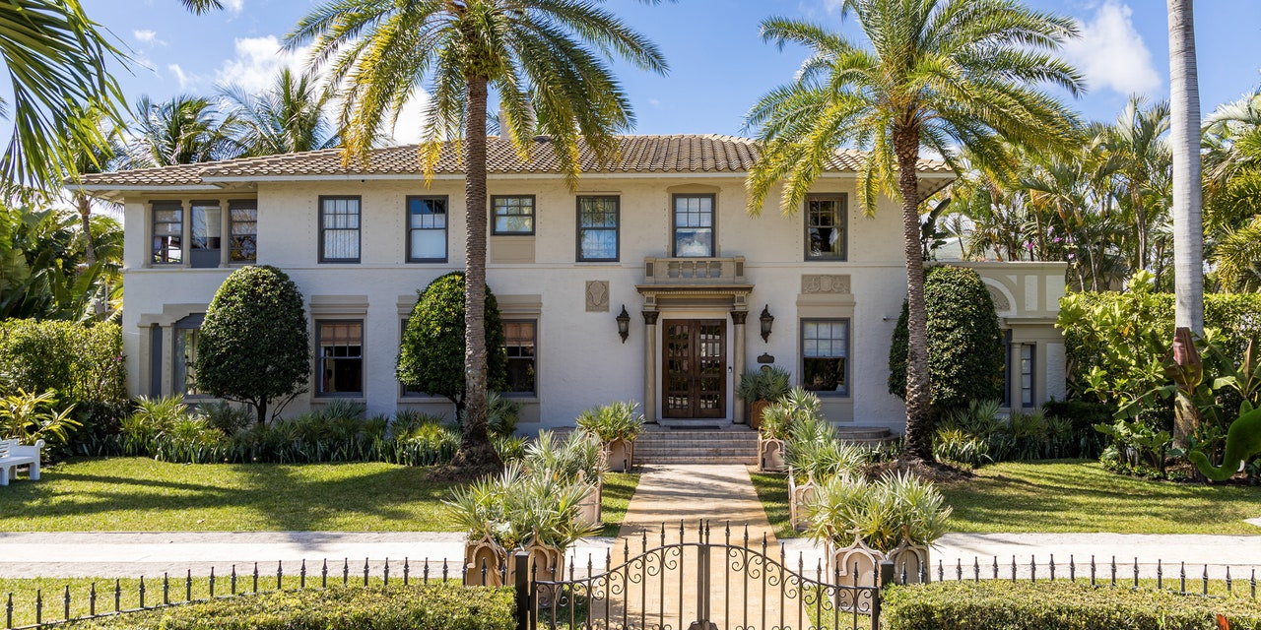

The Kips Bay Decorator Show House has completed another successful year in Palm Beach. With proceeds benefiting the Kips Bay Boys & Girls Club, twenty-four of the top industry leaders embarked on a journey to transform their given space into an enrapturing display of style and ingenuity. Marking the fifth annual showhouse set in Palm Beach, the 1920s home in the Old Northwood Historic District was entwined with bold color and pattern. Each room told a distinct story illustrating each designer’s unique perspective, something we adore to see.

Take a peek at some of our favorite rooms of The Kips Bay Decorator Show House Palm Beach 2022.
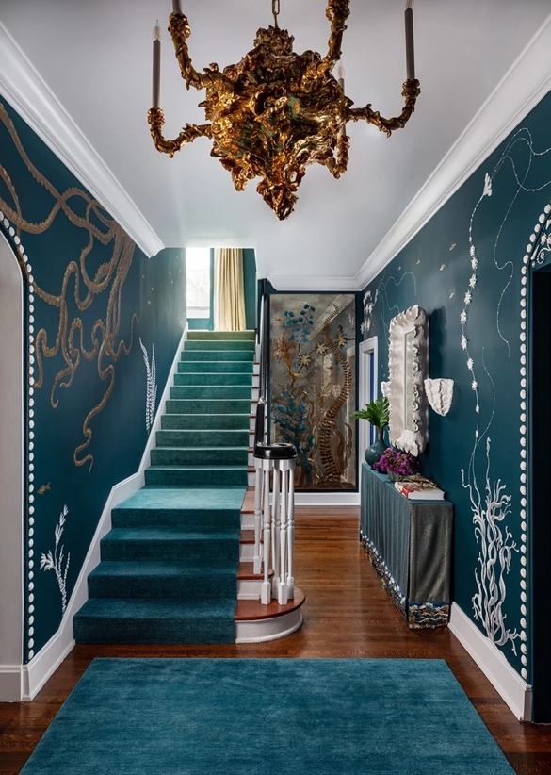
The entryway by Craig & Company is feast of blues with incredible wall treatment done by MJ Atelier.

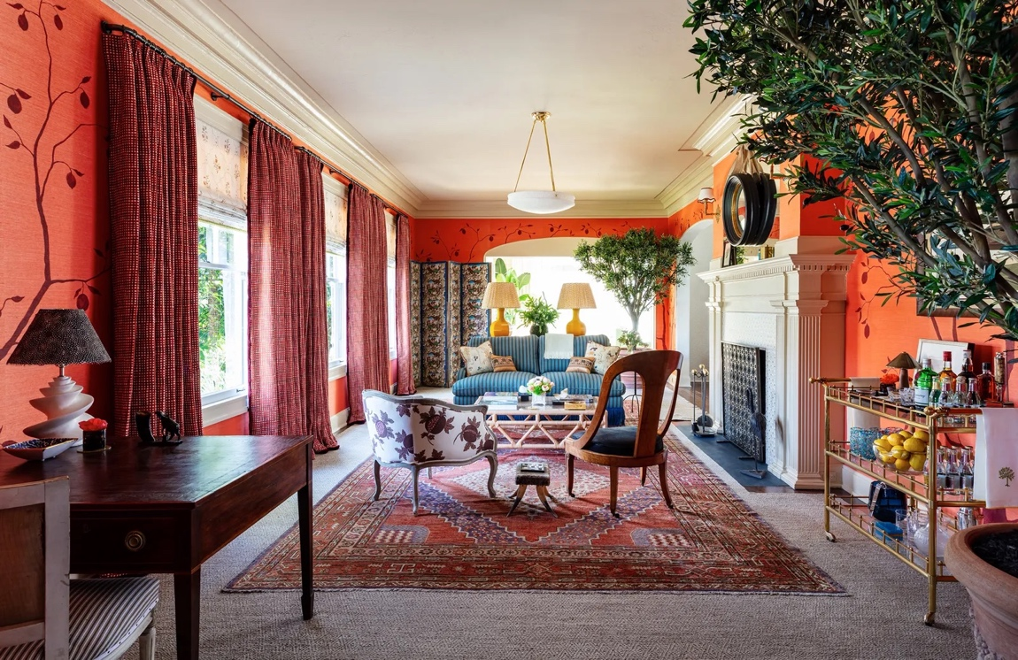

The vibrant orange drawing room by Peter Pennoyer Architects.

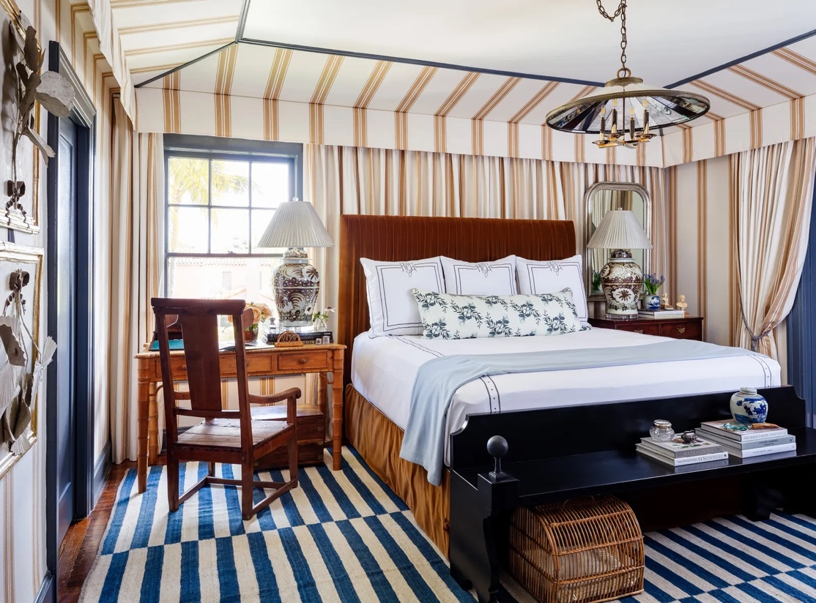

A stripey moment with classic silhouettes by Ashley Gilbreath Interior Design.

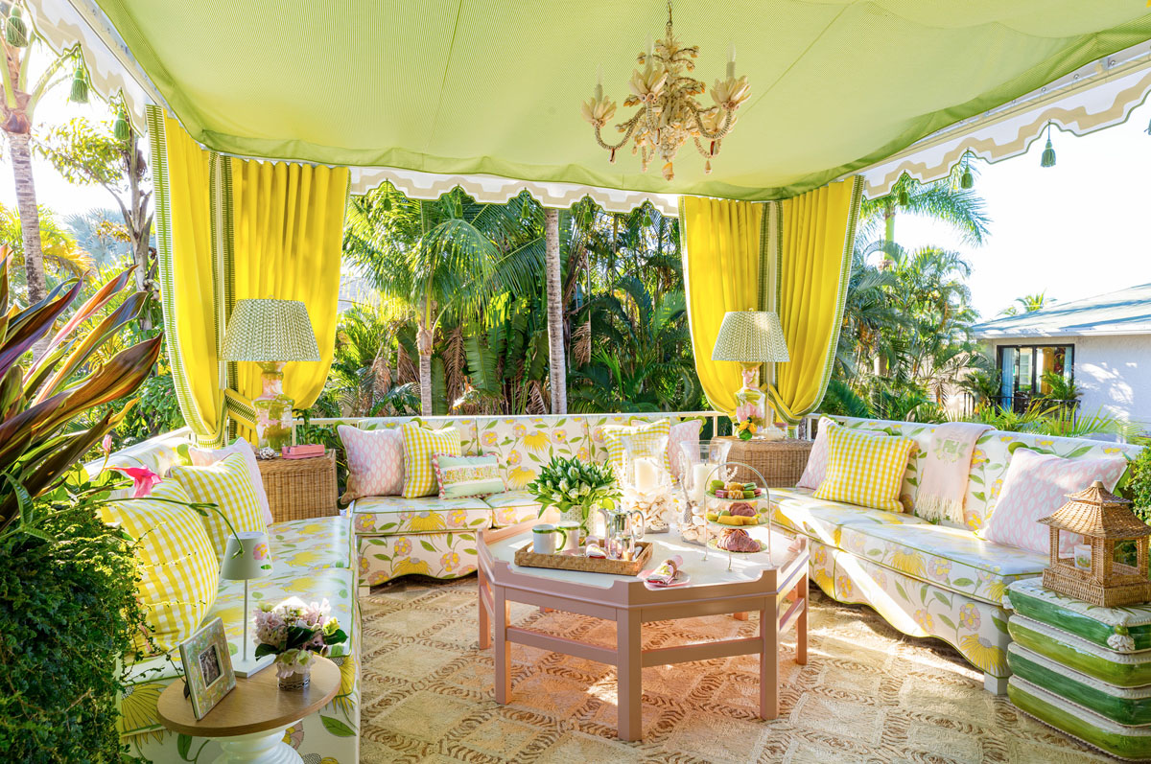

A punchy balcony with a mid-century twist ready for entertaining by Amanda Reynal Interiors.

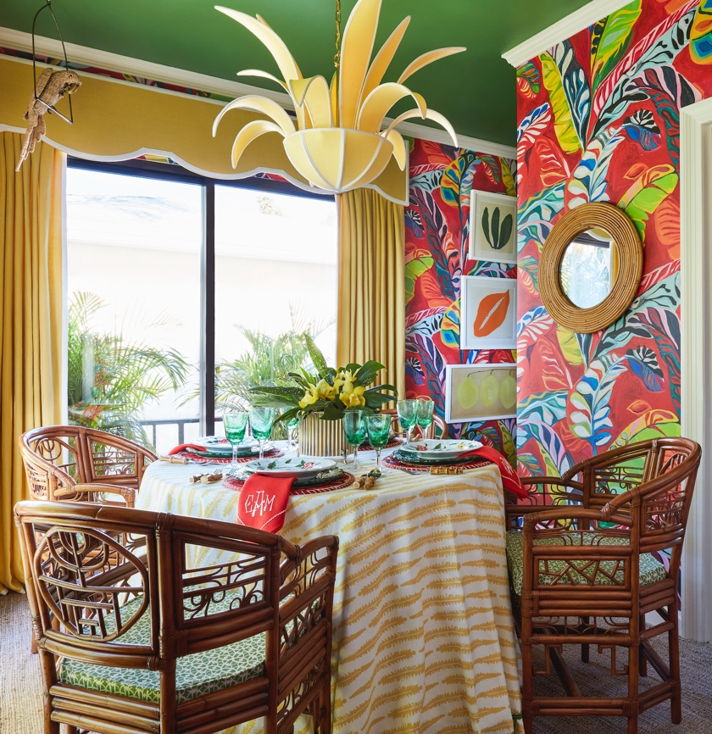

The “Jewel of the Jungle” guest house designed by Catherine M. Austin

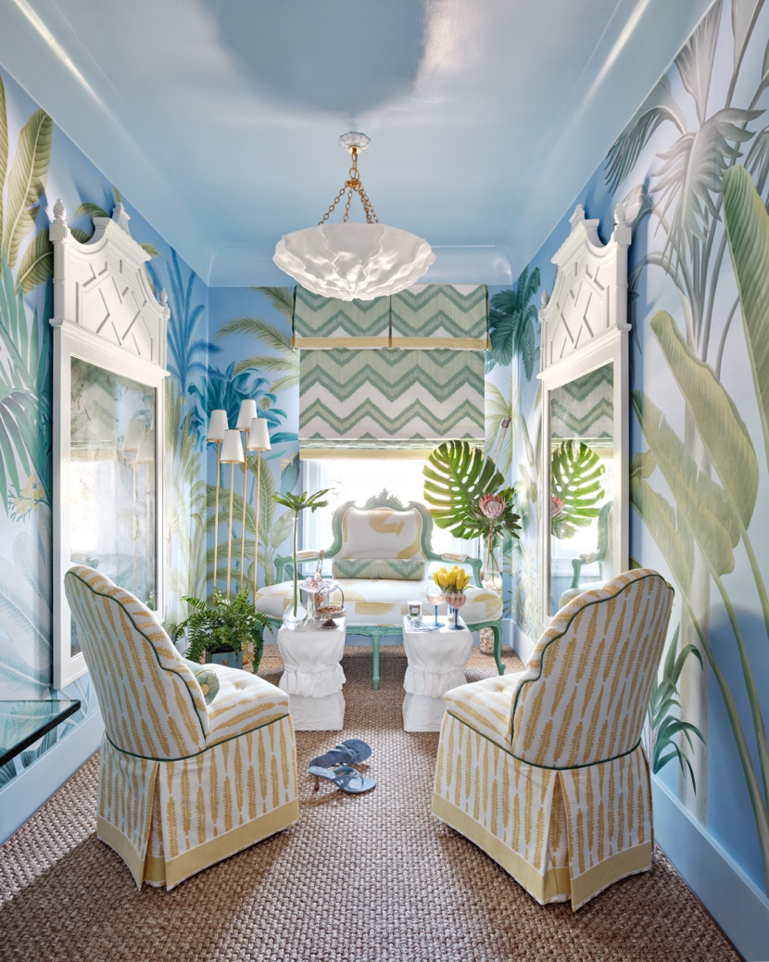
“The Closet Reimagined" by The Lewis Design Group

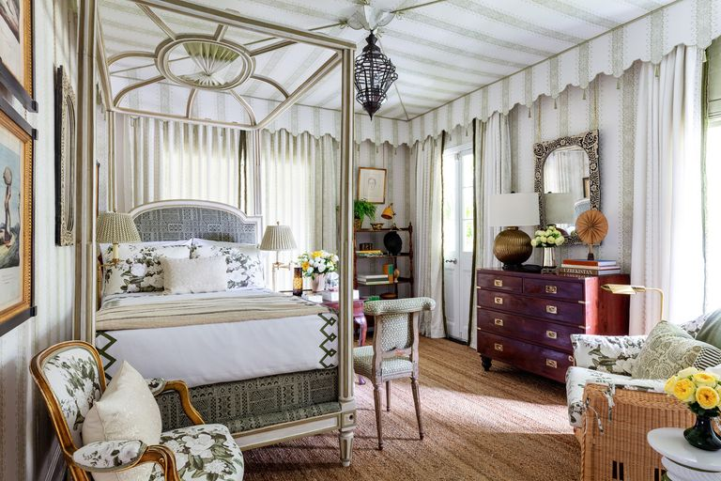

An English gentleman meets Tangier by Nashville designer Sarah Bartholomew.

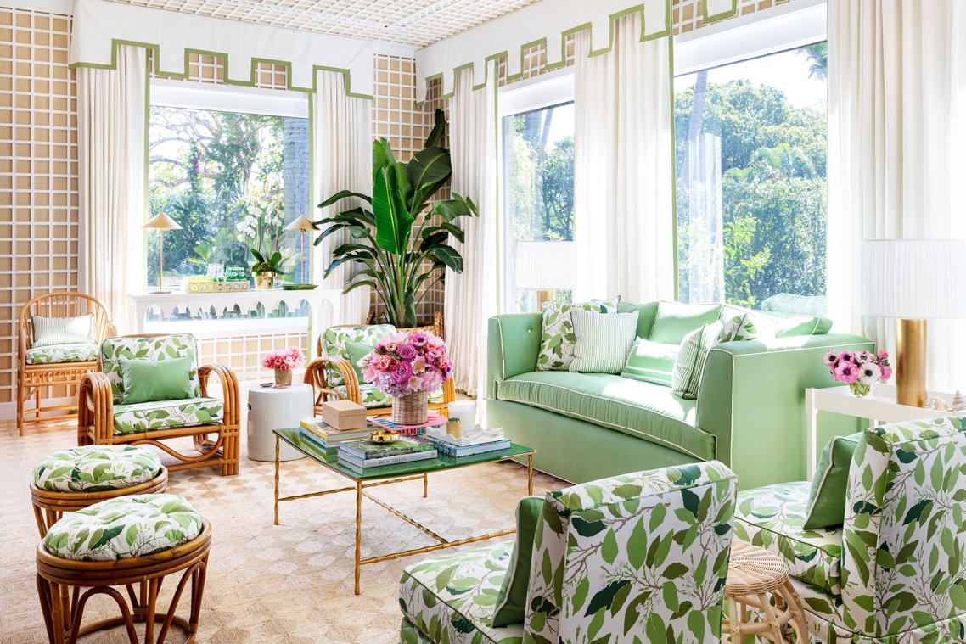

The treillage clad sunroom by Paloma Contreras

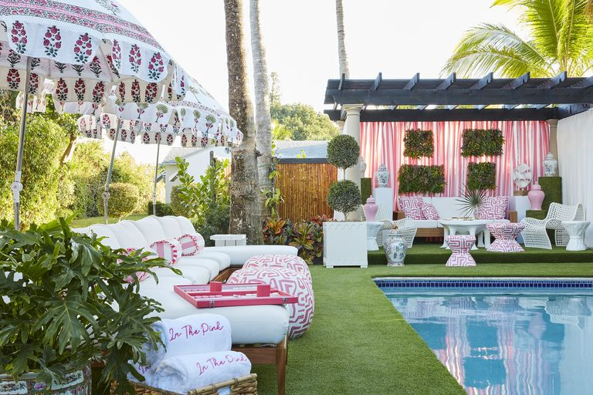

Pink poolside oasis by Janie Molster.

With such an array of talent and spaces to discover within the showhouse, it is hard for us to pare down our selection of favorites. Congratulations to all the inimitable designers who left their mark on the beautifully restored “Mansion of Northwood.”
Learn more about the Kips Bay Showhouse and. Kips Bay Boys & Girls here.

Images: Carmel Brantley and Nicholas Sargent

