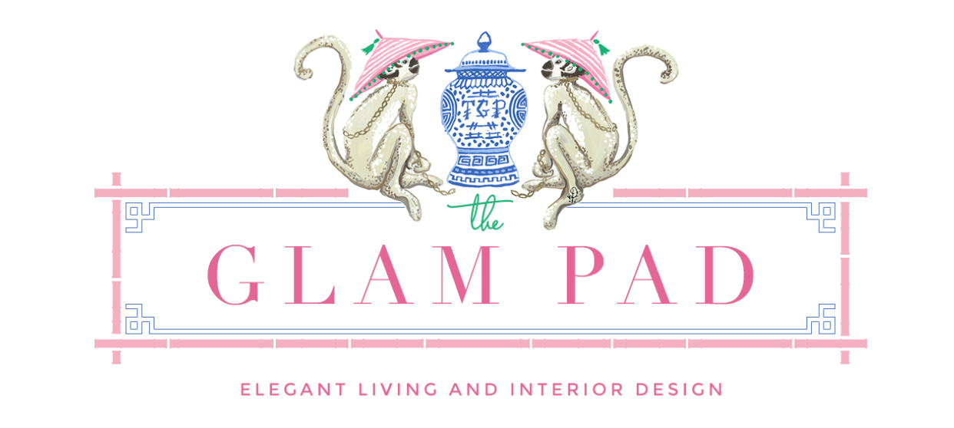

SOCIAL MEDIA INFLUENCER CONTRACT

- THE PARTIES. This Social Media Influencer Contract (“Contract”) made this March 4, 2022 is by and between:

Advertiser: Paige Wilson with a mailing address of 9311 B Metric Blvd, Austin Texas, 78758 (“Advertiser”), and

Influencer: Andrea Kavanagh with a mailing address of 2801 Milton Avenue, Dallas, Texas 75205 (“Influencer”).

The Advertiser and the Influencer are individually referred to herein as a "Party" and collectively as the “Parties.”

- COMMENCEMENT AND DURATION. This Agreement is to commence upon arrival date of Pretty Kennel. This Contract is for:

☐ A Fixed-Term. The Parties agree to this Contract shall terminate after all obligations outlined below have been met. After termination, the Parties shall have no obligations or liabilities to one another.

- CONTENT REQUIREMENTS. The Influencer shall make social media postings for the Advertiser as described:

- Inclusion in the "Pretty Home Necessities for Puppy!" blog post mid-late March with images from Pretty Kennels’ website and The Glam Pad (TGP)’s pictures with Riley, TGP’s French Bulldog
- Promotion on TGP Instagram, Instagram stories, and Pinterest for above mentioned blog post.
- Style Profile Q&A in late-March/early-April including pictures from Paige Wilson’s home, and a picture of Riley. Paige will have full approval prior to publication.
- Promotion of Style Profile on TGP Instagram, Instagram stories, and Pinterest.
- Photography and video of Riley with his new Pretty Kennel for Pretty Kennels’ full usage.
- Pretty Kennels may also have access to pictures/video posted @thelifeofrileyfrenchie<https://www.instagram.com/thelifeofrileyfrenchie/>. Here, TGP will document his growth, including in his Pretty Kennel!

Hereinafter known as the “Content.”

The Content will contain any tags, links, or titles the Advertiser requests to be included in the uploaded media.

- SOCIAL MEDIA PLATFORMS. The Content shall be published on the following Influencer’s social media profiles: Instagram, Pinterest, and www.theglampad.com

- PAYMENT. The Advertiser agrees to pay the Influencer in the following manner:

☐ - Products: Gifted Medium Pretty Kennel

Hereinafter known as the “Payment Amount.” The Influencer understands that they are being paid as an independent contractor and responsible for the payment of all appropriate local, state, and federal taxes.

- CONFIDENTIALITY. The Influencer must:

  - Avoid disclosing confidential or proprietary information by any means necessary that is not authorized by the Advertiser to any third parties, both during the term of this Contract and for at least one (1) year following its termination.
  - Avoid making copies or duplicating the Advertiser’s confidential and proprietary information unless directed to do so by the Advertiser;
  - Only use specific information provided by the Advertiser for use that is explicitly authorized by the Advertiser; and
  - Inform the Advertiser immediately if they become aware of unauthorized disclosure or use of any potential confidential or proprietary information.

Failure of any of the above may result in the termination of this Contract and legal action against the Influencer.

- ADVERTISER LEGAL REQUIREMENTS. The Influencer is not responsible for any legal, technical, or regulatory specifications regarding the Advertiser’s business; this is the sole responsibility of the Advertiser.

- INDEMNIFICATION. The Advertiser and the Influencer will each defend, indemnify, and hold the other harmless, including, but not limited to, affiliates, successors, assigns, employees, agents, and officers) against all losses, damages, deficiencies, liabilities, awards, penalties, or expenses of whatever kind, including attorneys’ fees and related legal fees, incurred by themselves in connection with any claims, suits, actions, demands, or judgments arising out of this Contract.

- SEVERABILITY. If any portion of this Contract shall be held invalid or unenforceable for any reason, the remaining provisions shall continue to be valid and enforceable. If a court finds that any provision of this Contract is invalid or unenforceable, but that by limiting such provision, it would become valid and enforceable, then such provision shall be deemed to be written, construed, and enforced as so limited.

- GOVERNING LAW. This Contract shall be construed and governed in accordance with the laws located in the State of Texas.

- FORCE MAJEURE. The Influencer is not liable for cessation or delay of work due to forces beyond their reasonable control, including but not limited to acts of God, military action, riots, and acts of nature.

- ENTIRE CONTRACT. This Contract constitutes the entire contract between the Parties. No modification or amendment of this Contract shall be effective unless in writing and signed by both Parties.

- EXECUTION. The Advertiser and the Influencer each represent and warrant to the other that each person executing this Contract on behalf of each Party is duly authorized to execute and deliver this Contract on behalf of that Party.

Advertiser’s Signature: ____________________________ Date: _______________

Print Name: ____________________________

Influencer’s Signature: ____________________________ Date: _______________

Print Name: ____________________________

